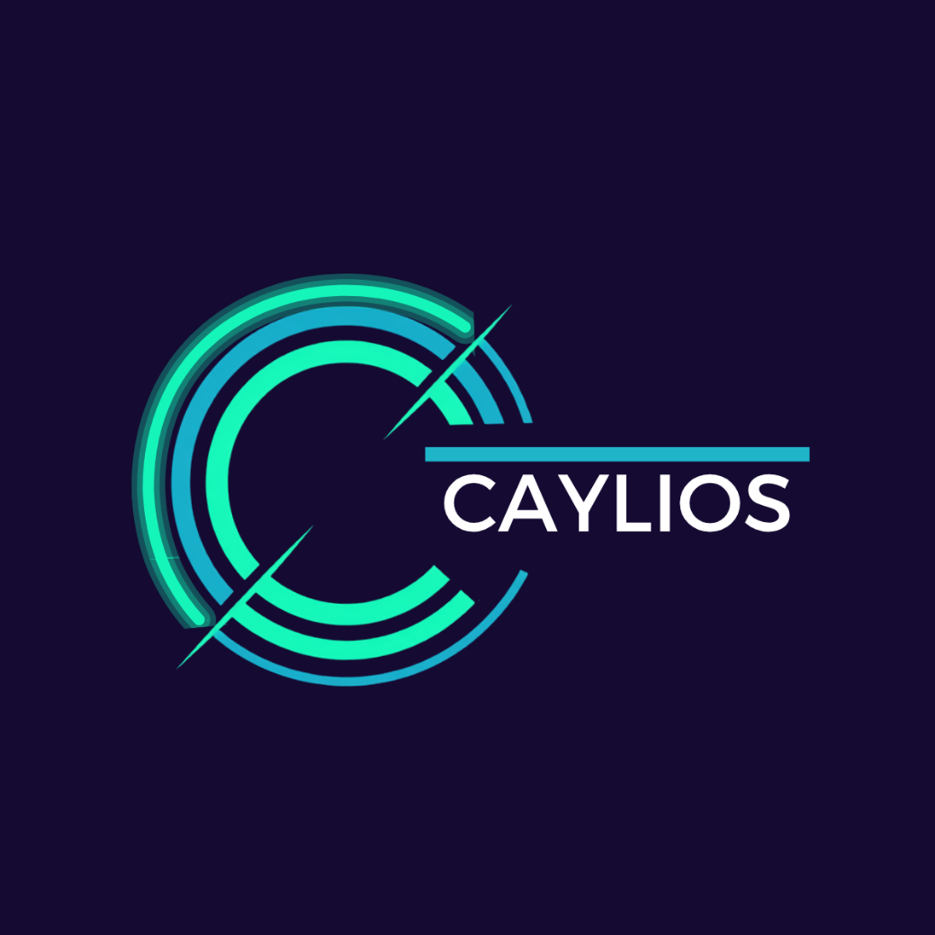

BRAND KIT

8 July 2026
BY KYLIE STEWART

Table of Contents
Table of Contents 2
Document Information 4
Purpose 4
Version Control 4
Introduction 5
Brand Identity 6
Brand Name 6
System 6
Pronunciation 7
Meaning 7
Brand Protection 7
Brand Foundation 8
Tagline 8
Strategic Brand Idea 8
Elevator Pitch 8
Value Proposition 8
Brand Positioning 8
Brand Purpose 9
Mission Statement 9
Brand Promise 9
Messaging Framework 10
Core Message 10
Customer Benefits 10
Key Messaging Pillars 10
Brand Personality 10
Brand Voice 11
Website Messaging 12
Hero Headline 12
Subheading 12
Call To Action 12
Taglines 13
Strategic Anchor 13
Primary Expression 13
Supporting Themes 13
Logo 14
Logo Composition 14
Logos 14
Logo Icons 15
Simplified Logo Icons 16
Wordmarks 17
Layout Rules 19
Logo Usage Rules 19
Logo Colour Application 19
Primary Logo 19
Single Coloured Logos 19
Colour Palette 21
Brand Colours 21
Colour Meaning 21
Usage Rules 21
Typography 22
Primary Typeface 22
Secondary Typeface 22
Typography Hierarchy 23
Typography Size Rules 23
Typography Principles 23
Brand Image Principles 24

Document Information

Purpose
This document defines how Caylios communicates its value across all external channels. It ensures consistent messaging as the business scales, so all teams, partners, and contributors express the brand clearly and consistently.
It exists to:
- Reduce ambiguity in communication
- Prevent message drift
- Ensure consistent representation across all touchpoints
- Support clear, confident articulation of value

Version Control
VERSION | PURPOSE | DISTRIBUTED | DATE
0.01 | Draft | Internal
1.0 | FINAL | Directors
1.1 | Updated with shape and icon libraries | Directors
2.0 | Repositioning of brand to focus on customer | Directors | 1 July 2026
2.1 | Minor update to messaging swapping in moves for flow | Directors | 3 July 2026
3.0 | Removal of visual library to new visual guide + formats | Directors | 4 July 2026
4.0 | Change of name to Caylios and associated updates | Directors | 6 July 2026
4.01 | Addition of Brand Protection and typo correction | Directors | 7 July 2026
4.02 | Updated Logo section with full set of logos and logo icons and associated changes. | Directors | 8 July 2026

Introduction
The Brand Kit works alongside the Visual Language Guide as complementary documents.
The Brand Kit defines the identity of Caylios — including naming, messaging, tone, and core visual identity rules.
The Visual Language Guide defines how that identity is executed in practice — including layouts, components, icons, diagrams, and implementation structures.
Together, these documents ensure consistency between how Caylios is defined and how it is visually applied across all outputs.
Where the two documents overlap, the Brand Kit defines identity and naming rules, and the Visual Language Guide defines execution and implementation. In all cases, the Brand Kit takes priority for identity and naming conventions.

Brand Identity
Brand Identity defines the core identity of Caylios, and ensures the brand is represented consistently across both visual identity and written communication. It provides a structured system for applying the brand consistently across all brand touchpoints.

Brand Name
CAYLIOS
Caylios is a distinctive proprietary brand name. It should always be used as a single word and never abbreviated or substituted with acronyms.

System
The Caylios brand uses two casing formats depending on context:
CAYLIOS (Visual Identity Form)
Used when the brand is displayed as a visual identity element.
Use cases:
- Logo
- Wordmark
- Headers and UI elements where the brand is presented as a mark
- Marketing visuals and brand applications
- Structured headings and UI labels where the brand name is used as a standalone identifier (e.g. slide titles, dashboard headers, section headers)
Caylios (Written Language Form)
Used in sentence-based communication for readability.
Use cases:
- Body text
- Written descriptions
- Articles, proposals, and documentation narrative
- Conversational or editorial content
RULE
The casing of the logo defines the visual identity standard (CAYLIOS). Written language may use sentence case for readability.

Pronunciation
Caylios is pronounced: CAL-ee-oss
You can include this in two formats depending on context:
Standard - Caylios (pronounced CAL-ee-oss)
Brand kit version - Pronunciation: CAL-ee-oss

Meaning
Caylios is derived from Cameron (Ca) + Kylie (yli) + Operating System (OS). This represents the foundation of the business - people + systems.
Note: this is internal narrative and not required for customer-facing messaging.

Brand Protection
The Caylios name, logo, wordmark, and associated brand assets are proprietary intellectual property of the business.
The business intends to register and maintain appropriate trademark protection for the Caylios brand in relevant jurisdictions. Until registration is complete, all brand assets should be treated as protected proprietary material and used only in accordance with this Brand Kit.
Any proposed variations, derivative marks, or third-party use must be approved by the Directors.

Brand Foundation
Brand Foundation defines the core identity of Caylios, including purpose, positioning, messaging, and value. It establishes Caylios as a platform that helps unlock hidden capacity by removing operational friction and improving how work moves through a business. It ensures all communication remains aligned, intentional and customer focused.
Caylios uses a delivery model to implement operational improvements while the platform is being developed.
Caylios operates a three-layer value system:
- Hidden Capacity defines the strategic insight behind the platform
- Make Work Simple defines the operational approach used to deliver value
- Unlocking Hidden Capacity defines the resulting outcome of using the platform

Tagline
Make Work Simple

Strategic Brand Idea
Every business has hidden capacity. Caylios unlocks it.

Elevator Pitch
We help businesses unlock hidden capacity by removing operational friction and redesigning how work moves through their business. This gives teams more time, more control, and the ability to scale without increasing workload.

Value Proposition
Caylios is a platform that helps businesses unlock hidden capacity by removing operational friction and improving how work moves through their business. It turns inefficient and manual processes into streamlined systems that reduce workload, free up time, and enable businesses to scale without adding headcount or complexity.
These improvements progressively become part of a scalable operational platform over time.

Brand Positioning
Caylios is a platform-led business that helps organisations unlock hidden capacity by improving how work moves through their operations.
While the Caylios platform is in development, the business operates through a structured delivery model that designs and implements operational improvements. This delivery model exists to generate revenue, support real-world implementation, and continuously inform the development of the platform.
Caylios helps businesses scale without increasing workload or operational complexity by turning inefficient workflows into structured, repeatable systems that progressively become part of a scalable platform.

Brand Purpose
To unlock hidden capacity in businesses by removing operational friction and simplifying how work moves through everyday operations.

Mission Statement
To help businesses gain back time and capacity by improving how work moves through their operations through structured systems that form the foundation of a scalable platform.

Brand Promise
We help businesses unlock capacity and reduce operational strain by improving how work moves through their systems.

Messaging Framework
The Messaging Framework defines the core language used to express the value of Caylios. It ensures consistent communication of how hidden capacity is unlocked by reducing operational friction and improving workflow across a business. It provides a structured system of messages, benefits, and pillars to ensure clarity and alignment across all communication.

Core Message
Unlock hidden capacity by removing operational friction and improving how work moves through a business.

Customer Benefits
Gain back time across teams | Reduce operational load | Unlock hidden capacity without hiring
Improve movement of work across systems | Scale without increasing complexity | Reduce manual and repetitive work
Increase control and visibility over operations

Key Messaging Pillars
Hidden Capacity | Uncover unused operational capacity inside your business
Operational Friction | Remove inefficiencies that slow work down
Movement of Work | Improve how work moves through teams and systems
Scalability | Grow without increasing headcount or complexity
Clarity & Control | Gain visibility over operations

Brand Personality
Practical | Clear | Professional
Reliable | Straightforward | Modern
Minimal | Clean | Streamlined

Brand Voice
We sound like
Clear and direct | Simple language | Human tone
We do NOT sound like:
Buzzword heavy | Overly technical | Corporate jargon | Abstract or vague

Website Messaging
Website Messaging defines how Caylios is communicated in digital environments. It ensures visitors immediately understand how Caylios unlocks hidden capacity by improving how work moves through a business.

Hero Headline
Make Work Simple

Subheading
We help businesses unlock hidden capacity by removing operational friction and improving how work moves through everyday operations.

Call To Action
Unlock hidden capacity

Taglines
Taglines define the short-form expressions of Caylios used for recognition and recall. They reinforce both the emotional outcome (Make Work Simple) and strategic positioning (unlocking hidden capacity).

Strategic Anchor
Every business has hidden capacity. Caylios unlocks it.

Primary Expression
Make Work Simple

Supporting Themes
Workflow simplification | Cost reducing through automation | Operational improvement
Productivity gains | Before Vs after process improvements | Business efficiency wins
Practical | High clarity | Productive

Logo
The Logo section defines the Caylios visual identity and the approved logo assets used across digital, print, merchandise, and product applications.
The logo system includes the full logo, logo icons, simplified logo icons, and wordmarks. Together they provide a consistent visual identity across all formats while ensuring suitable artwork is available for both digital and production use.
All logo assets must be used only as defined within this Brand Kit.

Logo Composition
The primary logo consists of three elements:
- Icon
- Wordmark
- Horizontal accent line
These elements form the complete Caylios logo and must not be separated, rearranged, or modified unless using an approved alternate logo asset.

Logos
Primary (Full colour – Midnight Indigo, Digital Teal, Electric Mint and White)
Used across all primary brand applications including:  - Website  - Platform  - Proposals  - Presentations  - Marketing material  - Corporate communications | 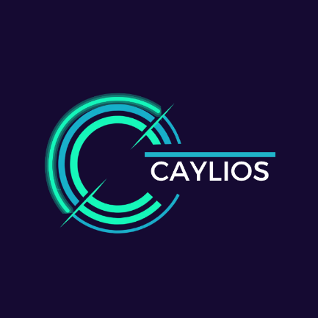
Primary (Transparent)
The transparent version is the preferred asset wherever the background is controlled by the application. | 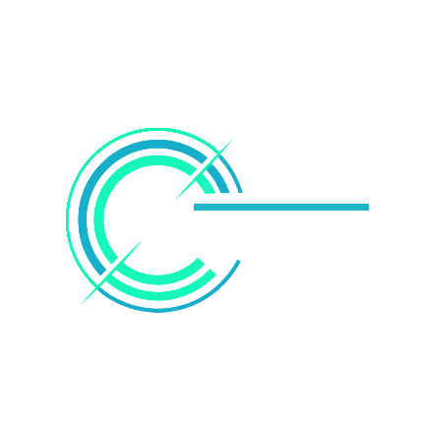
Reverse (White)
Used on dark backgrounds where maximum contrast is required. | 
Midnight Indigo
Used on white or light backgrounds. | 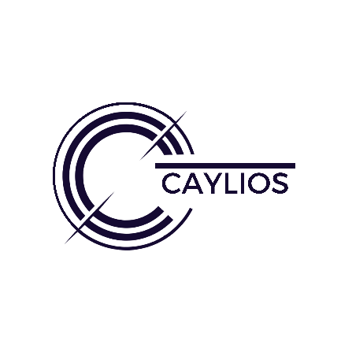
Digital Teal
Approved accent version for selected merchandise and promotional applications. | 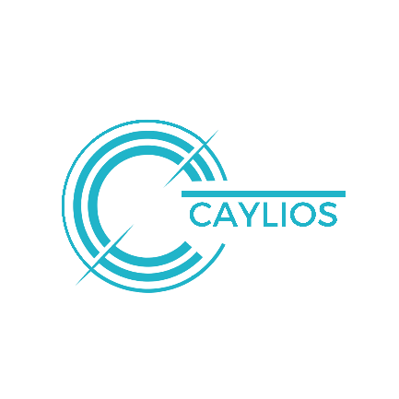
Electric Mint
Approved accent version for selected merchandise and promotional applications. | 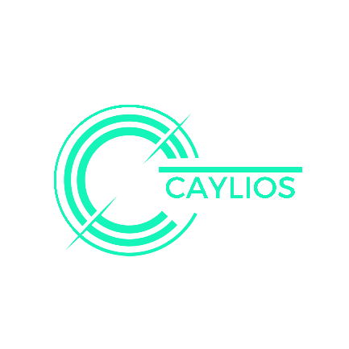

Logo Icons
Logo icons are used where the full logo is not practical due to space or application constraints.
Primary
Used for:  - Website  - Applications  - Dashboard  - Social Media  - Favicons  - Marketing material | 
Primary (Transparent)
Preferred where the application provides its own background. | 
Reverse (White)
Approved production icon for dark backgrounds. | 
Midnight Indigo
Approved production icon for light backgrounds. | 
Digital Teal
Approved production icon. | 
Electric Mint
Approved production icon. | 

Simplified Logo Icons
Simplified logo icons are provided for applications where reduced detail improves recognition or production quality.
Simplified
Used for:  - Favicons  - Small UI elements  - Low-resolution environments  - Embroidery  - Engraving  - Small merchandise  - Applications where rapid recognition is preferred over detail | 
Simplified (Transparent)
Approved colour variant. | 
Reverse (White)
Approved colour variant. | 
Midnight Indigo
Approved colour variant. | 
Digital Teal
Approved colour variant. | 
Electric Mint
Approved colour variant. | 

Wordmarks
Light
Used on dark backgrounds where white text provides high contrast and clear brand visibility. This includes:  - Website headers and hero sections with dark or Midnight Indigo backgrounds  - Presentation title slides with dark layouts  - Formal documents and proposals using dark background themes  - Marketing materials where dark surfaces are used for emphasis  - Any application where white (#FFFFFF) ensures readability  Style:  - Text colour: White (#FFFFFF)  - Typeface: Montserrat  - Weight: Regular  - Case: ALL CAPS  - Line height: 1.4  - Letter spacing: 0  - Background: Midnight Indigo (#150A32) or other approved dark surfaces | CAYLIOS
Dark
Used where the wordmark must appear on light or white backgrounds with high contrast. This includes:  - Documents and reports with white backgrounds  - Print materials  - Slides or presentations with light layouts  - UI or web sections with light themes  - Any application where Midnight Indigo (#150A32) or dark text ensures clarity and readability  Style:  - Text colour: Midnight Indigo (#150A32)  - Typeface: Montserrat  - Weight: Regular  - Case: ALL CAPS  - Line height: 1.4  - Letter spacing: 0  - Background: White (#FFFFFF) or light neutral surfaces | CAYLIOS

Layout Rules
Maintain strict hierarchy across Caylios logo elements:
Primary Logo
↓
Wordmark
↓
Logo Icon
↓
Simplified Logo Icon
Do not visually compete, invert hierarchy, or substitute one asset where another is more appropriate.

Logo Usage Rules
- Respect the built-in clear space contained within each logo asset.
- Use only approved logo assets contained within this Brand Kit.
- Do not stretch, distort, rotate, redraw, or recreate any logo element.
- Do not alter colours outside the approved brand palette.
- Do not apply gradients, shadows, glow effects, outlines, or other visual effects.
- Use the logo version that provides the greatest clarity and contrast for the application.
- Use simplified logo icons where production methods or small sizes require reduced detail.

Logo Colour Application

Primary Logo
ELEMENT | COLOUR | HEX CODE
Inner Circle | Electric Mint | #15F5BA
Middle Circle | Digital Teal | #20B4C9
Outer Circle | Electric Mint (neon effect) | #15F5BA
Diagonal Elements | Electric Mint | #15F5BA
Horizontal Accent Line | Digital Teal | #20B4C9
Wordmark | White | #FFFFFF

Single Coloured Logos
Approved single-colour logo assets may be reproduced entirely in:
- White (#FFFFFF)
- Midnight Indigo (#150A32)
- Digital Teal (#20B4C9)
- Electric Mint (#15F5BA)
Within a single-colour asset, all logo elements must use the same colour. No individual elements are to be recoloured independently.

Colour Palette
The Colour Palette defines the official brand colours used across all visual materials. It establishes the role of each colour and how they should be applied in design and communication.
It is designed to ensure visual consistency, reinforce brand recognition, and maintain a clear and professional identity across all touchpoints.

Brand Colours
HIERARCY | COLOUR | PALETTE | HEX CODE
Primary | Midnight Indigo |  | #150a32
Secondary | Digital teal |  | #20b4c9
Accent | Electric mint |  | #15f5ba
Neutral | White |  | #ffffff

Colour Meaning
Our colour palette is built to balance trust, clarity, and energy within a modern technology-focused identity. It is designed to feel grounded and professional at its core, while still allowing space for bold, high-impact accents that communicate innovation and momentum.
Midnight Indigo | Serves as the primary brand colour, forming the foundation of the identity. It represents stability, depth, and reliability — reinforcing trust in the solutions we provide.
Digital Teal | Is the secondary colour, supporting the primary palette with a sense of clarity, intelligence, and approachability. It is used to add structure and variation across layouts while maintaining a consistent brand feel.
Electric Mint | Is the accent colour, used sparingly to draw attention to key actions, highlights, and moments of emphasis. It represents energy, efficiency, and transformation.
White | Acts as the neutral base and default background colour, ensuring simplicity, readability, and strong contrast across all brand materials.

Usage Rules
Midnight Indigo | Leads all core branding elements (logos, headers, key identity areas)
Digital Teal | Supports structure, sections, and secondary emphasis
Electric Mint | Is reserved for calls-to-action (CTAS), highlights, and key points of focus
White | Is the default background to maintain clarity and simplicity

Typography
Typography plays a key role in creating a consistent and professional brand experience. The Caylios typography system has been selected to balance a modern technology-focused identity with strong readability across digital, print, and presentation materials.
It is designed to ensure that all communication feels clear, structured, and easy to read, while still maintaining a strong and recognisable brand presence.

Primary Typeface
Montserrat | Montserrat is the primary typeface for the Caylios brand. It is used for the logo, headings, and key messaging.  Its clean, geometric style reflects the brand’s focus on simplicity, modern technology, and structured thinking.  Montserrat is used when we want to create impact, hierarchy, and strong visual identity.
Recommended Usage | Logo: Montserrat  Main Headings (H1): Montserrat Bold  Section Headings (H2): Montserrat Bold  Sub-headings (H3): Montserrat Medium  Key Statements / Emphasis Text: Montserrat Bold (as needed for clarity and emphasis)

Secondary Typeface
Calibri | Calibri is the supporting typeface used for body text and longer-form content.  It has been selected for its high readability, especially in digital environments, while still complementing the modern and structured feel of Montserrat.  Calibri is used when clarity and ease of reading are the priority.
Recommended Usage | Body Text: Calibri Regular  Minor Headings: Calibri Bold  Captions / Notes: Calibri Regular  Supporting Content (documents, reports, proposals): Calibri Regular  Forms / Instructions / Explanatory Content: Calibri Regular

Typography Hierarchy
This hierarchy ensures consistent structure across all documents and materials.
ELEMENT | TYPEFACE | WEIGHT | SIZE | SPACING
Logo | Montserrat | Bold | As per logo system (Caylios lockup rules) | As per logo system (no paragraph spacing rules apply)
H1 Heading | Montserrat Black | Bold | 36–44pt | 18pt above / 6pt below  starts on new page  acts as section divider
H2 Heading | Montserrat | Bold | 24–30pt | 12pt above / 6pt below
H3 Heading | Montserrat | Medium | 18–22pt | 6pt above / 6pt below
Body Text | Calibri | Regular | 11pt | 6pt above / 6pt below
Captions / Notes | Calibri | Regular | 11pt | 6pt above / 6pt below
Table Headings | Calibri | Bold | 11pt | 6pt above / 6pt below
Table Rows | Calibri | Regular | 11pt | 3pt above / 3pt below

Typography Size Rules
- Sizes are designed for Canva, Word, and presentation use
- Use the lower end of the range for dense documents
- Use the higher end of the range for presentations and marketing material
- Do not create additional heading levels outside this system
- Do not manually scale text outside these defined ranges

Typography Principles
- Use Montserrat for structure and emphasis (headings, branding, key messages)
- Use Calibri for readability and explanation (anything longer or instructional)
- Avoid introducing additional fonts unless there is a clear and approved business need
- Maintain consistent font usage across Canva, Microsoft Office, website content, and all external communications
- Prioritise clarity over styling — if something becomes harder to read, simplify it

Brand Image Principles
Visuals should simplify complexity and support understanding of how work moves through a business. All visual execution is defined in the Visual Language Guide to ensure consistency across systems.

